Costa Blanca

Road Cycle Routes from Calpe

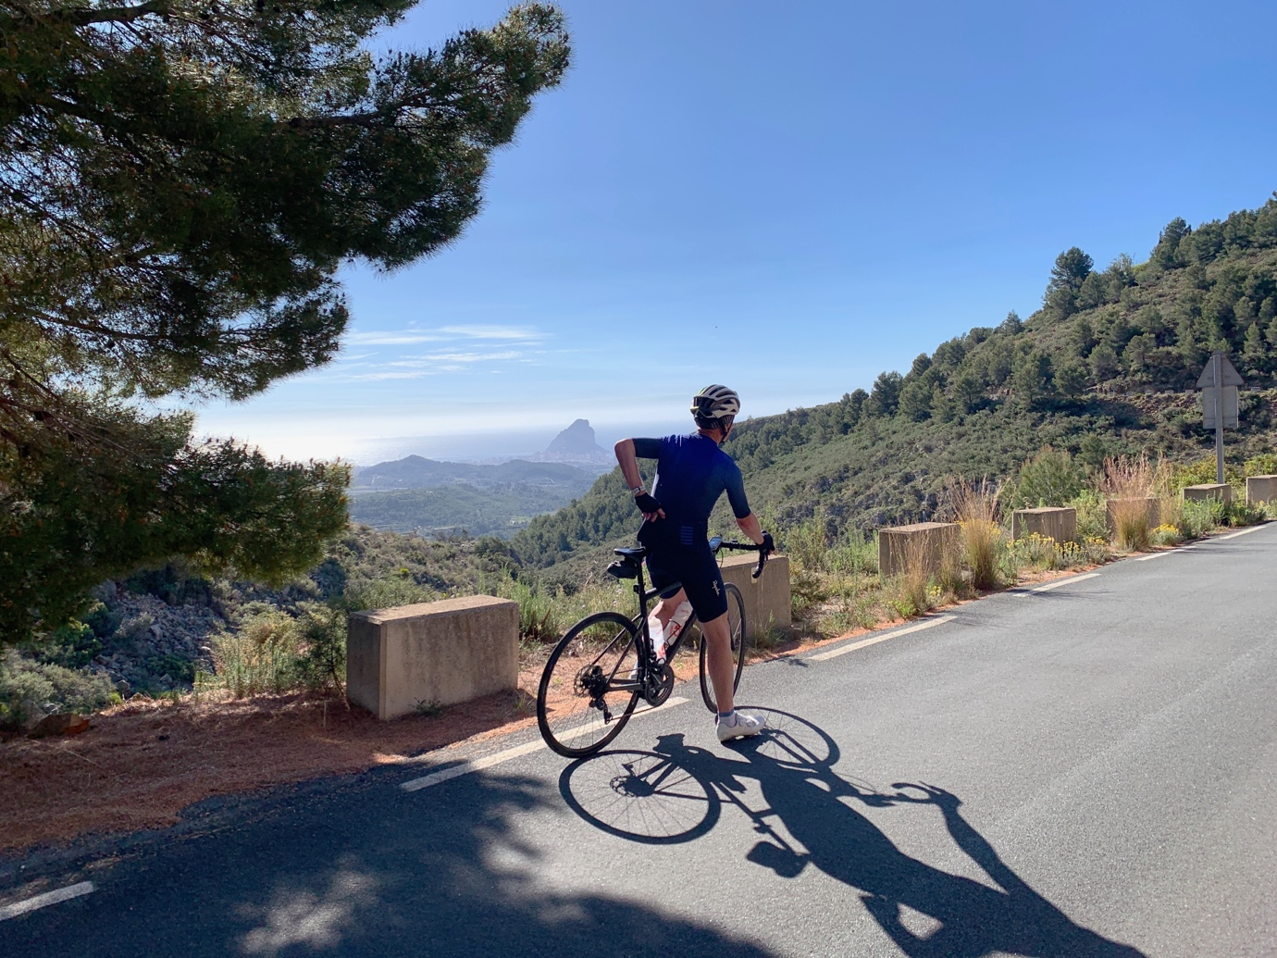

Andy Leach April 2024

The Costa Blanca Area

Scenery
The Costa Blanca region is home to some excellent mountainous scenery. It doesn't take long to leave the more resort orientated towns of the coast behind and enter quiet and beautiful mountains, with rocky peaks and pine forests dominating the landscape.
The climbs closer to the coast offer views looking out over the Mediterranean, although the better scenery is to be found inland.

Mountains
The Costa Blanca region is mostly home to medium mountains, with the climbs generally between 500m and 1000m altitude. However, because you start many of these from near sea-level, they can still involve quite considerable climbing.
There are several mountain ranges, including the Sierra Aitana and Sierra de Mariola. These ranges hold all kinds of climbs, ranging from long and gentle, to short and steep. Most of the climbs on these routes are more modest in length (5km to 10km) and gradient (5% to 7%) than you get in the Pyrenees, Alpes & Dolomiti.

Roads
The road surfaces are of a consistently excellent quality throughout the region and are a pleasure to ride on a road bike.
Nearly all the climbs are very quiet, particularly once you get away from the coast. On many routes you can ride for long periods of time without seeing a single car. The coastal area is quite developed and although Spring is a low season for “beach tourists”, the routes mostly go inland to avoid the traffic. But don’t be surprised if you see Pro teams in the area. The quiet, silky smooth roads and gradual climbs have made it a popular training ground.

This Guide
This guide provides links to 25 circular routes on Garmin Connect, all starting in Calpe. They include flatter coastal rides and longer ones that will take you to the mountains. They will take you to some of the most spectacular scenery in the Costa Blanca.

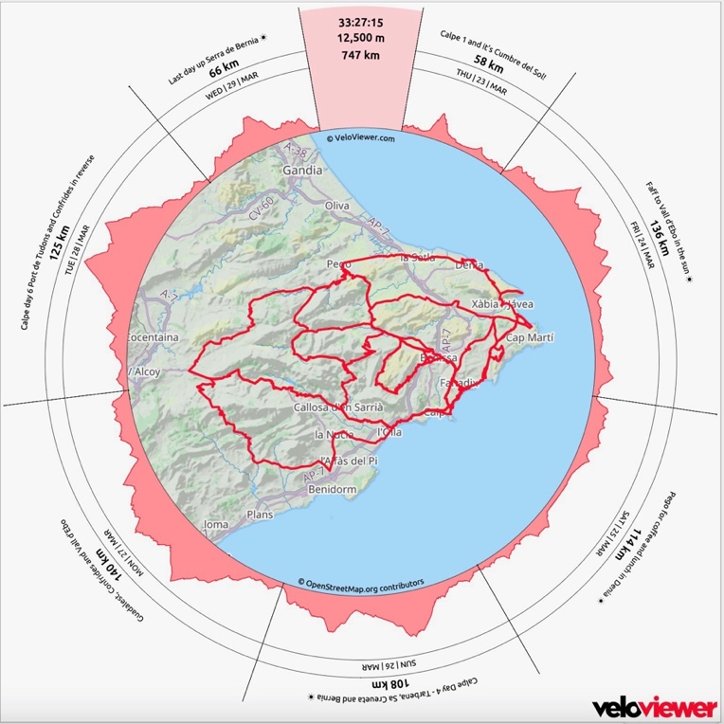

The Famed Climbs

Coll de Rates
Routes Calp 07, 08, 09 (N to S); Calp 03, 05 (S to N)

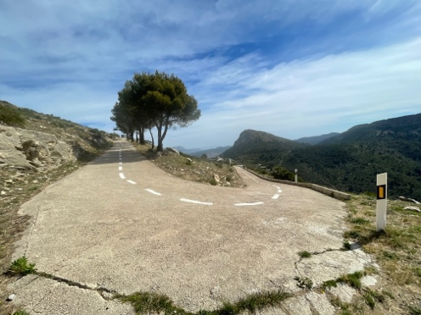
‘Coll de Rates is the blue ribboned climb of the area. At 6km, with an average gradient of 5 per cent, it's short and shallow enough that it's perfect for FTP type efforts.
The smooth gradient, excellent views and stunning surface makes for a great descent, too - just look out for those riding in the other direction and so 'on the limit' that the white line is all a bit of a blur.
At the top we have Coll de Rates 2.1 – the definition of a hidden incline. Hundreds of cyclists pass this place everyday but none of them knows that this little gravel path leads to the most magical uphill around. It’s only 2.6km long but the average grade is 11%.’

Port de Tudons
Routes Calp 03, 04, 20, 21
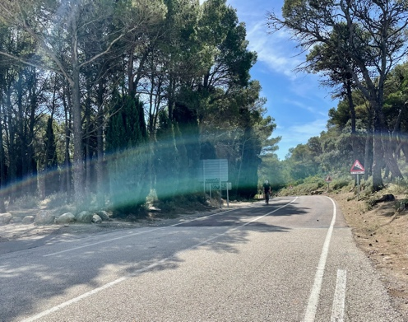
‘Puerto de Tudons is a favourite with pro riders and has featured in the Vuelta a España a number of times. In total, the climb is around 17 km long with a 4.5% average gradient. Gradients are gentle in the opening few kilometres but get steeper around Sella. Sella sits in a dramatic location with a vertical mountain backdrop. It’s probably a good point for a cafe/bar stop – some of the places on the main street have great views from the balconies. This area has the best scenery on the climb with views of the spectacular Puig Campana mountain. As you leave Sella behind you, the gradients steepen, and the views become obscured by trees’.

Port de Confrides
Routes Calp 02, 03, 14

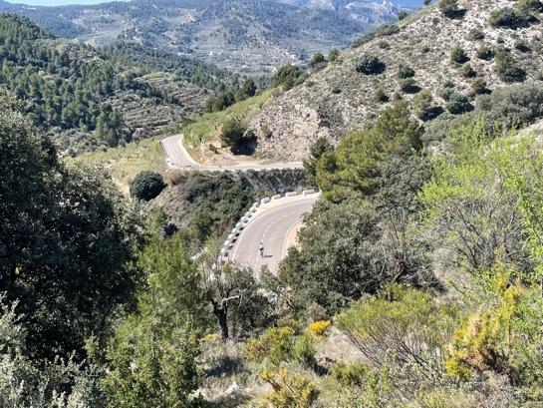
‘Port de Confrides is undoubtedly one of the best climbs in the Costa Blanca region. Reaching nearly one thousand metres of altitude, it is a long ascent, but the gradients are gentle and so it's not overly challenging.
The scenery here is spectacular with great views of the Sierra Aitana mountains and the impressive Guadalest reservoir. You also pass through charming villages, such as Castell de Guadalest and Confrides, which make for a great coffee stop.’

Vall d’Ebo
Routes Calp 02, 03
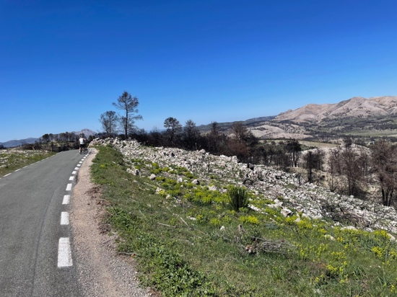
‘Very much a 'testers climb', the 8km stretch from Pego winds its way to the summit at an average gradient of 6 per cent with no specific ramps to disrupt your flow. The constant switchbacks provide plenty of opportunity to take in the valley views - or check out the progress of your ride buddies.

Beware - if you climb from Pego and continue on to Tollos after the summit, you'll be greeted with a further 15km of rolling terrain that offers some seriously stinging ramps. It's well worth leaving a little energy in the tank, go too hard on the climb and you might find yourself tempted to get off the bike and call a taxi home.’

The Climbs in detail

Climb Name | Direction | Length Km | Height gain  M | Ave Grad % | Max Grad % | Ridden on Route | Summit M | Comments by Cycle Fiesta
Puerto de Confrides | Callosa (E to W) | 20.4 | 735 | 3.6% | 5.5% | Calp 02 | 968 | Port de Confrides is undoubtedly one of the best climbs in the Costa Blanca region. Reaching nearly one thousand metres of altitude, it is a long ascent, but the gradients are gentle and so it's not overly challenging. The climb kind of begins from the town of Callosa d'en Sarriá, but it's rolling most of the way until you reach the bridge across the Guadalest River, at which point it becomes more sustained climbing until the village of Castell de Guadalest. The scenery here is spectacular with great views of the Sierra Aitana mountains and the impressive Guadalest reservoir. You also pass through charming villages, such as Castell de Guadalest and Confrides, which make for a great coffee stop.
Puerto Vall d'Ebo | La Vall d'Ebo to Pego (W to E) | 3.4 | 161 | 4.7% | 6.5% | Calp 02, 09 | 575 | Beautiful! Puerto de Ebo follows the CV-712 from Vall d'Ebo, heading over the pas towards the Costa Blanca. This is a short and fairly easy climb, with regular gradients. It is very popular with professional cyclists staying in nearby towns, who include Ebo as part of long circular rides. Port d'Ebo has a very good surface throughout and there is very little traffic on the climb.
Puerto de Confrides | Beniarda (W to E) | 7.6 | 357 | 5.2% | 9.0% | Calp 03 | 968 | Port de Confrides is one of the most enjoyable climbs in the Alicante province. The gradients are mostly gentle, with just a couple of steeper hairpins towards the top of the climb. The scenery here is very picturesque, from the almond and olive fields around the villages of Benilloba and Benasua, to the more winding mountainous scenery as you get closer to the pass.
Puerto de Tudons | Sella (S to N) | 17.0 | 740 | 4.4% | 7.0% | Calp 03, 20, 21 | 1024 | Port de Tudons is one of the most popular cycling climbs in the Valencia Community, and this is the classic side. It has featured several times in the Vuelta a España, often quite early in the stage rather than being a decisive climb. The gradients are fairly gentle and consistent, but the length makes it a moderately challenging climb. The scenery is very picturesque, particularly on the lower slopes, where there are views of the spectacular Puig Campana mountain. At the top of the climb there is a road to the right which continues climbing to Aitana; however, this is a military base and is very rarely open to the public.
Tarbena | Bolulla (S to N) | 7.1 | 390 | 5.4% | 9.0% | Calp 03, 05, 19, 21 | 557 | Tàrbena is a picturesque cycling climb in the mountains of the Alicante province. It is a short and fairly gentle climb and is great when included as part of a longer route in the area. This area is a very popular training ground for professional cyclists, particularly in the winter, and is also a great area for cyclo-tourists. The road is in very good condition throughout and there is generally little traffic on the climb.
Puerto de Tudons | Penaguila (N to S) | 8.3 | 352 | 4.3% | 7.0% | Calp 04 | 1024 | The ascent from Penàguila is quite short and steady. The scenery here is very nice, with switchbacks on the lower slopes offering impressive views back into the valley. The road is in fairly good condition, though it is slightly bumpy at times. There is very little traffic on the climb.
Puerto de Tudons | Alcoleja (N to S) | 5.0 | 298 | 5.8% | 8.0% | Calp 04 (alt to Penaguilla) | 1024 | The gradients on all sides of the climb are gentle and consistent, but the length makes it a moderately challenging climb; although one which is best included in a longer route rather than done by itself. The ascent from Alcoleja is short and steady, with a maximum gradient of around 8%
Sa Creuta | Tarbena (W to E) | 7.6 | 261 | 3.4% | 15.0% | Calp 04, 08, 09 | 780 | Sa Creueta is more of an extension to other climbs, rather than a serious mountain in its own right. It is mostly gentle climbing until the final 400m, where the gradients kick up well into double figures. Sa Creueta is commonly used by professionals training in the area, who include it on longer routes, and it also has fantastic mountain scenery, for riders who prefer to take their and appreciate the surroundings! The road is in very good condition throughout and there is little traffic on the climb.
Coll de Rates | Parcent (N to S) | 6.5 | 340 | 5.2% | 7.0% | Calp 07, 08, 09 | 625 | Coll de Rates is one of the most popular cycling climbs in all of Spain. Throughout the year you will find amateurs and professionals alike both testing themselves on the ascent. From Parcent it is quite a short and gentle ascent, but there are many great possibilities to include it in a longer ride. There are beautiful views throughout much of the climb, particularly looking west towards the Costa Blanca and the attractive mountains of the Bernia range. The road surface is in very good condition throughout and there is little traffic on the climb.
Alto de Tollos | Beniaia (N to S) | 4.2 | 239 | 5.7% | 16.0% | Calp 10 | 825 | Alto de Tollos is a popular cycling climb with its slopes attracting both amateurs and professionals during their winter training camps. Until Beniaia the climb is quite gentle and comfortable to ride. However, after passing through the village, the road becomes very irregular with numerous pitches above 15% gradient. The climb finishes with a 300m stretch averaging nearly 14% before a false flat to the summit.  Frequently included as part of a longer route, Tollos crosses in between the mountains of Almudaina and Alfaro, with pleasant views of both at various points on the ascent. It also connects the Alcala Valley with the longer climbs to the south, such as Confrides.
Puerto Vall d'Ebo | Pego to La Vall d'Ebo (E to W) | 8.6 | 465 | 5.4% | 6.5% | Calp 10 | 575 | Port d'Ebo from Pego is a very scenic climb from the Costa Blanca in the east of Spain. It offers beautiful views of the coast as it winds over the Migdia mountains into the Ebo valley. It is one of the many climbs in the area that is popular with professional cyclists. The gradients on Port d'Ebo are quite gentle and consistent, enabling you to find a steady rhythm. It is open throughout the year and is one of the most highly recommended climbs in the area, thanks to the great scenery and the sweeping bends, which are a lot of fun to ride. Port d'Ebo has a very good surface throughout and there is very little traffic on the climb.
Cumbre del Sol | Alcasar | 3.2 | 387 | 11.9% | 17.0% | Calp 11  Optional for Calp 22, 23 (in reverse) | 410 | Cumbre del Sol from Alcasar is a short and steep cycling climb on the Costa Blanca, which shot to fame in 2015 when it hosted a stage finish of the Vuelta a España. The climb produced spectacular action, with numerous star riders cracking, before Tom Dumoulin eventually managed to claim the win. The gradient is consistently steep and there are numerous sections which are over 15%, with one sustained pitch at 18%. Watching the likes of Alejandro Valverde, Chris Froome and Joaquim Rodríguez all cracking at various times on the ascent, tells you all that you need to know about its difficulty!
Bernia | Xalo (N to S) | 12.6 | 439 | 3.5% | 10.0% | Calp 12, 19 | 624 | This climb from Xaló (Jalón) is one of three main routes into the Bernia mountains and, is probably the most enjoyable to ride. The gradients are gentle and relatively consistent, only very rarely exceeding 10% for short sections. It is also has pleasant scenery, riding through orange, lemon and olive groves, as well as some pine forest. At the top there are fantastic views of the peaks of the Sierra Bernia. The road surface has been repaved fairly recently and is good condition throughout the climb. There can be a bit of traffic here at weekends and in high season, but most of the time it is quiet. And even during peak times it is usually not all that bothersome.
Puerto de Confrides | Benilloba (W to E) | 10.7 | 466 | 4.4% | 12.0% | Calp 14 | 968 | Port de Confrides is one of the most enjoyable climbs in the Alicante province. The gradients are mostly gentle, with just a couple of steeper hairpins towards the top of the climb. The scenery here is very picturesque, from the almond and olive fields around the villages of Benilloba and Benasua, to the more winding mountainous scenery as you get closer to the pass.
Coll de la Garga | Sagra to Vall de Laguar | 10.8 | 654 | 6.1% | 17.0% | Calp 15 | 766 | La Garga is a very pleasant climb, rising up from the flatter plains of the Costa Blanca and finishing in the picturesque Vall de Laguar. For the most part it is not particularly challenging; however, the final 3km are tough, with several long sections in excess of 15% gradient. This is one of several scenic climbs in the area, with open, panoramic views throughout much of the ascent, making it a fine choice to include in a longer circular ride.

Note: Climbs are listed in route number order

The Routes
Click on the maps below to see the Garmin Connect route. Climbs and possible refreshment stops have been highlighted.

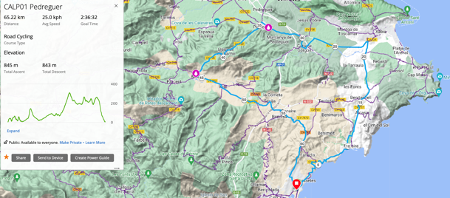
Calp 1 Pedreguer
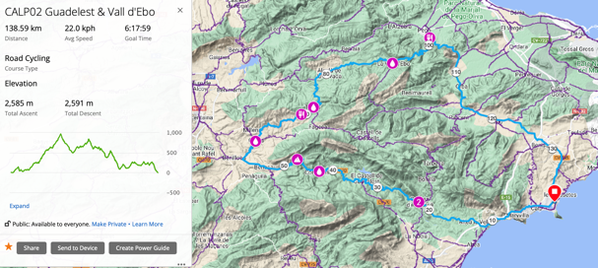
Calp 2 Guadelest & Vall d'Ebo
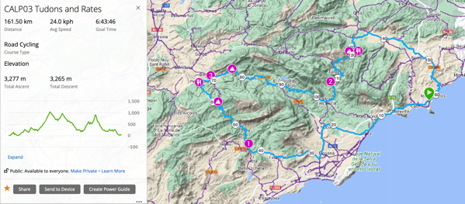
Calp 3 Tudons and Rates
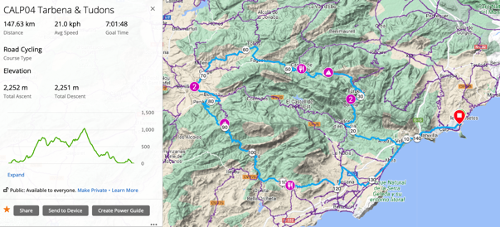
Calp 4 Tarbena & Tudons
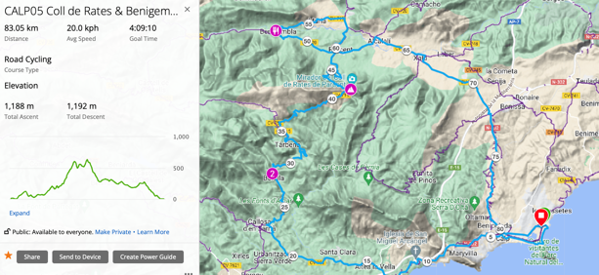
Calp 5 Coll de Rates & Benigembla
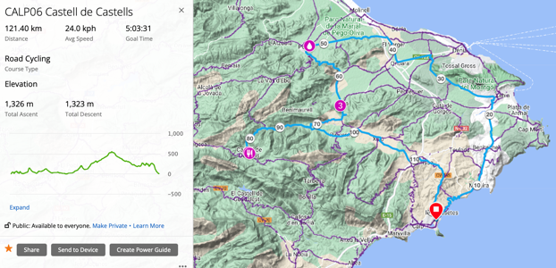
Calp 6 Castell de Castells
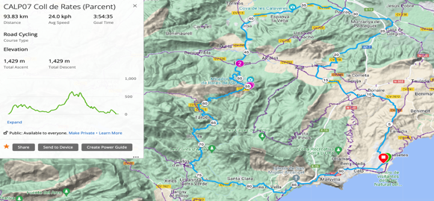
Calp 7 Coll de Rates (Parcent)
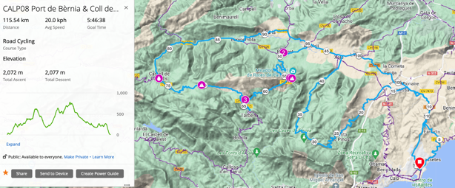
Calp 8 Port de Bèrnia & Coll de Rates
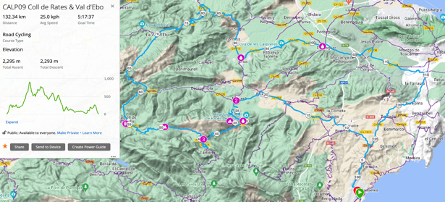
Calp 9 Coll de Rates & Val d'Ebo
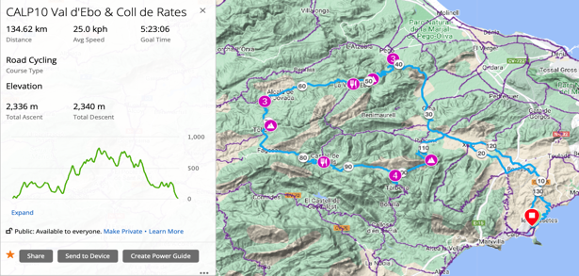
Calp 10 Val d'Ebo & Coll de Rates
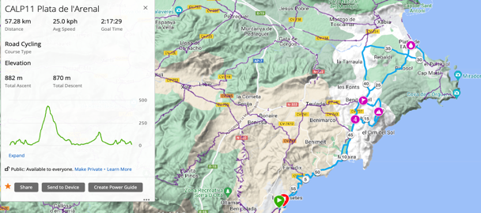
Calp 11 Plata de l'Arenal
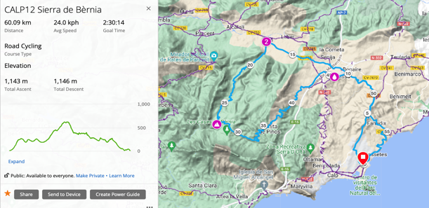
Calp 12 Sierra de Bèrnia
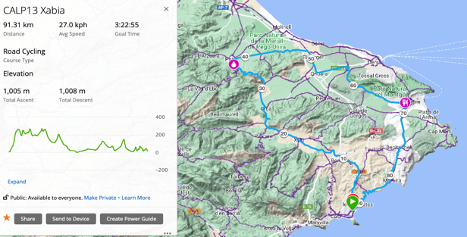
Calp 13 Xabia
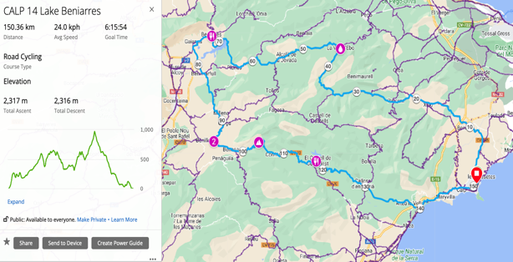
Calp 14 Lake Beniarres
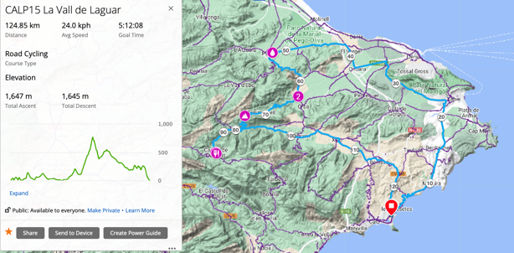
Calp 15 La Vall de Laguar
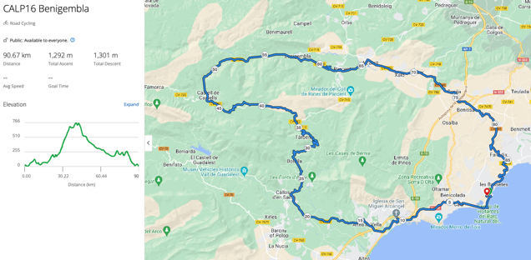
Calp 16 Benigembla
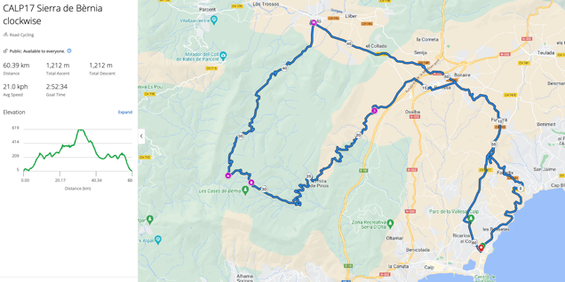
Calp 17 Sierra de Bèrnia clockwise
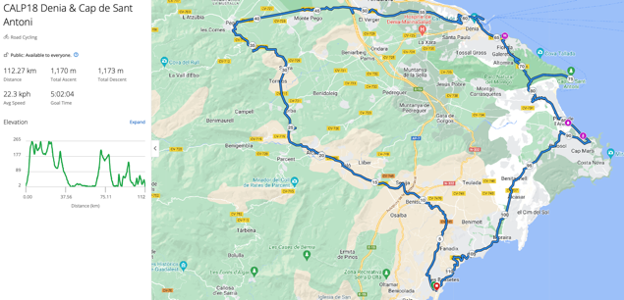
Calp 18 Denia & Cap de Sant Antoni
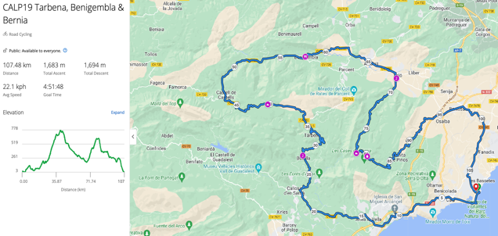
Calp 19 Tarbena, Benigembla & Bernia
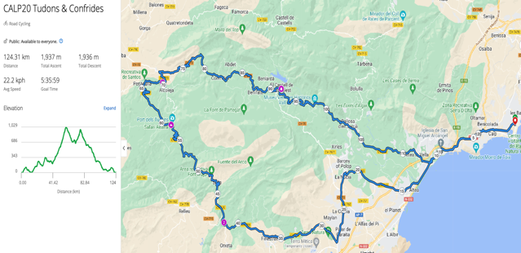
Calp 20 Tudons & Confrides
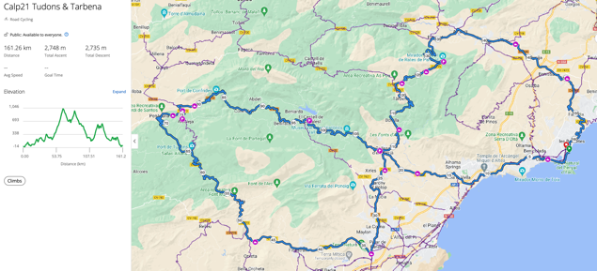
Calp 21 Tudons & Tarbena
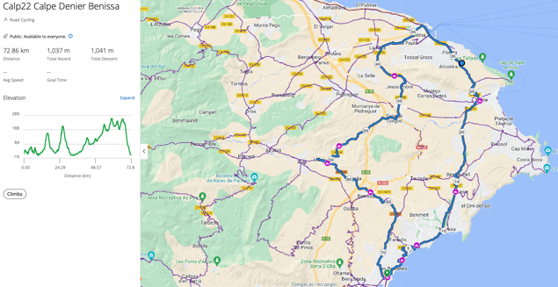
Calp 22 Calpe Denia Benissa

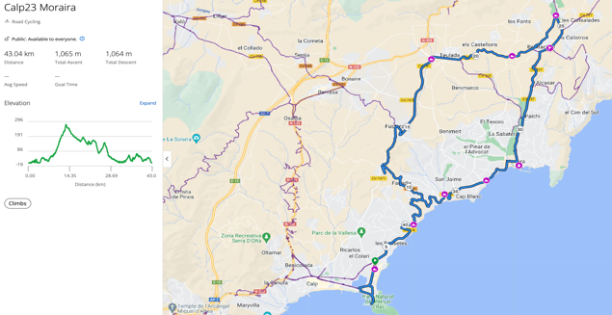
Calp 23 Moraira
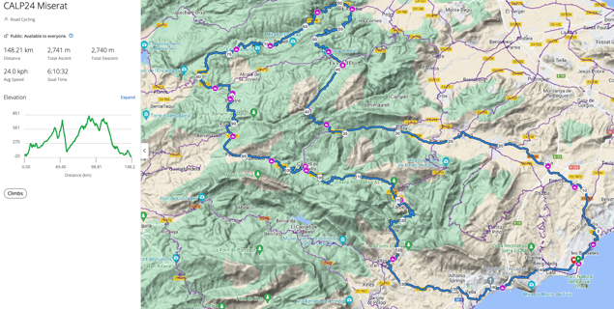
Calp 24 Miserat
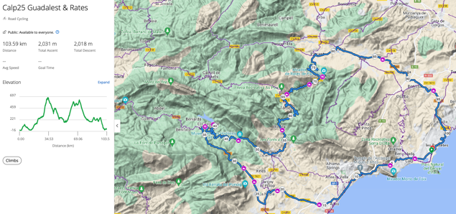
Calp 25 Guadalest & Rates
Note routes are sorted by Route name

Routes in detail
Click on route name for link to Garmin Connect route. Suggested café stops and the main climbs are noted on the route and will pop up on compatible Garmin devices. Routes are sorted by distance.

Ridden in 2023 | Route Title | Km | Miles | Mtrs | Ft | Noted climbs & comments | Stops | Inspiration/ Source
 | Calp23 Moraira | 43 | 27 | 1,050 | 3,413 | Shorter route to Moraira with option for Cumbre Del Sol on return | Moraira
Day 1 | CALP11 Plata de l'Arenal | 57 | 35 | 882 | 2,867 | Short café ride along north coast with optional challenge climb | Plata de l'Arenal | Vuelta climb Cumbre del Sol - 15% sections!
 | CALP12 Sierra de Bèrnia | 60 | 37 | 1,541 | 5,008 | Shake-down ride with beautiful Bernia climb | Benissa
Day 7 | CALP17 Sierra de Bèrnia clockwise | 60 | 37 | 1,212 | 3,939 | Coast rd climb to Benissa, up Bernia & down to Xalo | Top of Bernia, Xalo | Final day with spectacular views, but a cheeky bit near the top!
 | CALP01 Pedreguer | 65 | 40 | 845 | 2,746 | Shake-down ride; roads can get busy later in the day | Pedreguer
 | Calp22 Calpe Denia Benissa | 73 | 45 | 1,050 | 3,413 | Shorter route to Denier | Denia
 | CALP05 Coll de Rates & Benigembla | 83 | 52 | 1,188 | 3,861 | Shorter route up Col de Rates from Tarbena. Main road return (N332) | Benigembla | Van Vleuten
 | CALP13 Xabia | 91 | 57 | 1,005 | 3,266 | A shorter route going towards north coast with no major climbs and avoiding urban areas | Pego & Xabia
 | CALP16 Benigembla | 91 | 57 | 1,292 | 4,199 | Up Tarbena to Castell de Castell, Benigembla & Benissa | Tarbena, Castell de Castell, Parcent
 | CALP07 Coll de Rates (Parcent) | 94 | 58 | 1,427 | 4,638 | Vanilla route to Coll de Rates via Parcent | Top of Coll de Rates
 | Calp25 Guadalest & Rates | 103 | 64 | 2,000 | 6,500 | Coll de Rates from Tarbena | Guadaleast, Coll de Rates | Jo Ness
Day 4 | CALP19 Tarbena, Benigembla & Bernia | 107 | 66 | 1,683 | 5,470 | Tarbena, Castell de Castell, Benigembla & Bernia | Castell de Castell, Benigembla, Bernia | Nice route again - Part of CALP05 & 12
Day 3 | CALP18 Denia & Cap de Sant Antoni | 112 | 70 | 1,170 | 3,803 | Pego, Denia & Cap de St Antoni | Denia & Plata de l'Arenal | Away from the mountains. Part of CAlP13 & detour to Denier & Cap de St Antoni
 | CALP08 Port de Bèrnia & Coll de Rates | 115 | 71 | 2,223 | 7,225 | Bernia, Coll de Rates and on to quiet Sa Creueta | Top of Coll de Rates & Castell de Castells | Epic
 | CALP06 Castell de Castells | 121 | 75 | 1,326 | 4,310 | Longer route with no major climbs | Castell de Castells | Van Vleuten
Day 6 | CALP20 Tudons & Confrides | 124 | 77 | 1,937 | 6,295 | Tudons, Confrides | Alcoleja, Guadelest | Good but not quite as good as CALP02
 | CALP15 La Vall de Laguar | 125 | 78 | 1,658 | 5,389 | Similar to Calp 06 but with La Sagra climb up Vall de la Laguar | Castell de Castells | Van Vleuten
Day 2 | CALP09 Coll de Rates & Val d'Ebo | 133 | 83 | 2,341 | 7,608 | To the very top of Coll de Rates and on to quiet Sa Creueta | Coll de Rates, Castell de Castells & Pedreguer | Lovely route. The top of Coll de Rates has some 15%+ gradients!
 | CALP10 Val d'Ebo & Coll de Rates | 134 | 83 | 2,332 | 7,579 | Up the Vall d'Ebo and other quieter climbs | Val d'Ebo & Castell de Castells | Epic & Jon
Day 5 | CALP02 Guadelest & Vall d'Ebo | 138 | 86 | 2,585 | 8,401 | A longer route taking in the beautiful Port de Confrides climb & lovely Vall d'Ebo. Some remote areas so stops will be taken as seen | Gorga, Benimassot, Tollos, Vall d'Ebo & Pego | The best route of the week by far
 | CALP04 Tarbena & Tudons | 143 | 89 | 2,298 | 7,469 | A longer day with a moderate level of climbing in some remote areas | Castell de Castells & Finestrat | Van Vleuten
 | CALP24 Miserat | 148 | 92 | 2,750 | 8,938 | Miserat (from Vall d'Ebo, Port de sa Creueta | Vall d'Ebo, Castell de Castells
 | CALP03 Tudons and Rates | 161 | 100 | 3,277 | 10,650 | A grand day taking in some of the best scenery in the region. | Penaguilla & Coll de Rates | Epic
 | Calp21 Tudons & Tarbena | 161 | 100 | 2,750 | 8,938 | Tudons, Confrides, Tarbena | Alcoleja, Guadelest, Coll de Rates | Calp 03 with less main road at start
 | CALP14 Lake Beniarres | 155 | 96 | 2,430 | 7,900 | Vall d'Ebo, Lake Beniarres and Confrides circuit | Vall d'Ebo, Beniarres & Guadalest | Some beautiful remote scenary

Note: Routes are sorted by distance

The Calpe region of the Costa Blanca looks to offer plenty of mountain scenery and a range of climbs. There are also some flatter areas on offer, but with the prospect of having to use busier roads and towns. For this reason, the suggested itinerary tries to include a range of quieter routes with the promise of scenery (without excessive effort) and the possibility of flatter routes for a recovery day. There is a reasonably comprehensive selection of routes to choose from.

- There are 25 routes to choose from, although there is a degree of overlap, enabling you to mix and match or even reverse depending on the preferences of the group.
- The routes range from 60km (40miles) up to 160km (100miles), but they mostly have at least 1 climb of note
- To help acclimatise, the rides should be planned to get steadily more challenging (distance & climbing) as the week progresses, with suitable rest days as required
- Places that get recommended include Coll de Rates (routes Calp 03, 05, 10, 07, 08 & 09), Vall d’Ebo (routes Calp 02, 09 & 10), Tudons (routes Calp 03, 04 & 20) & Port de Confrides (Routes Calp 02, 03, 14)
- I have tried to identify suitable cafes/refreshment stops and they are noted on the routes (for compatible Garmins only). However, there is no guarantee that they will be open. In remote areas we will have to be opportunistic.
- There are more routes than you need, but this allows you to mix and change the itinerary
- Routes can obviously be done in either direction, but I have tried to plan them to get the best perspective & combination.

Road Safety
The routes try to take the quietest roads, however despite this they can be busy with other tourists and the lack of alternative routes for local traffic. The Calpe area is a popular tourist destination so we must expect some traffic in the coastal towns. As usual, I would suggest using front and rear lights at all times to maximise your visibility to other road users.

Weather
The weather is excellent for cycling throughout the year. The region has made a name for itself as a winter cycling destination, and with good reason. Daytime temperatures in December and January are often up around 20°C, making for very pleasant riding. Even when it gets 'cold', the passes nearly always remain open and are fine to ride if you put on a windproof jacket. Spring and Autumn are also excellent for riding, with pleasant temperatures. It's possible to ride in July and August as well, but you should play on making early starts to avoid the hotter times of the day. .

For more information about the area and the climbs we will be doing, see the following sources and links:

https://epicroadrides.com/destinations/cycling-spain/calpe-costa-blanca/#section-articles
https://www.cyclefiesta.com/multimedia/climbs/costa-blanca.htm
https://climbfinder.com/en/regions/valencia
https://www.cyclingcols.com/map
My Cols phone app

