Italian Dolomiti

Climbs and Routes from Corvara

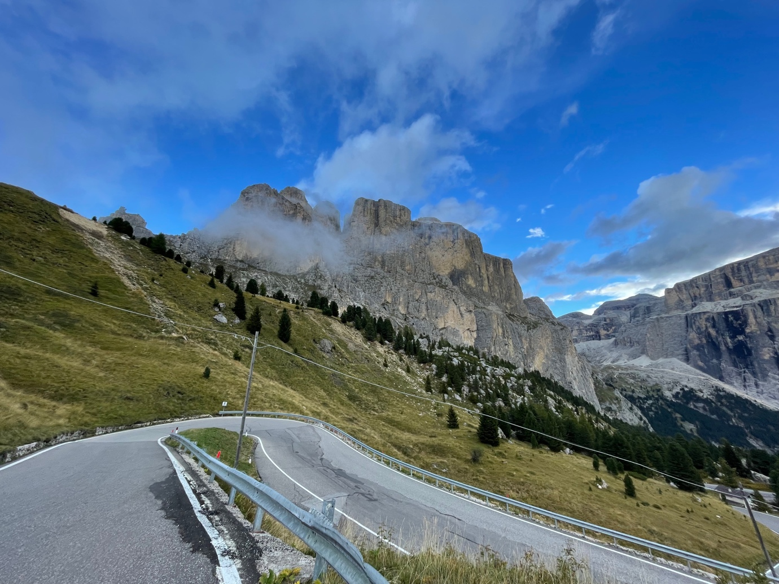

Andy Leach September 2022

The Climbs

Passo Campolongo
Routes Dol01,02,04,07,08,09, Maratona Short & Full 1 & 5

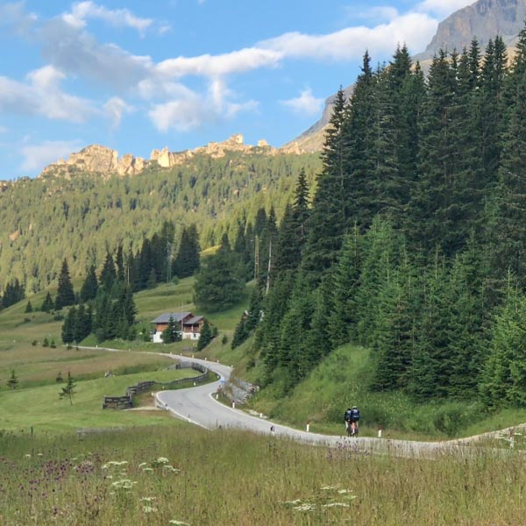
‘The unusual aspect of the Campolongo is the actual terrain. Most passes in the Dolomites have flat or virtually flat hairpin bends with the elevation kicking up on the straights. However, the Campolongo is completely the opposite with severe hairpins and straights that aren’t that steep! So, take note there are 13 hairpins on this pass!’

Passo Pordoi
Routes Dol01, 09, Maratona dles Dolomites Short & Full
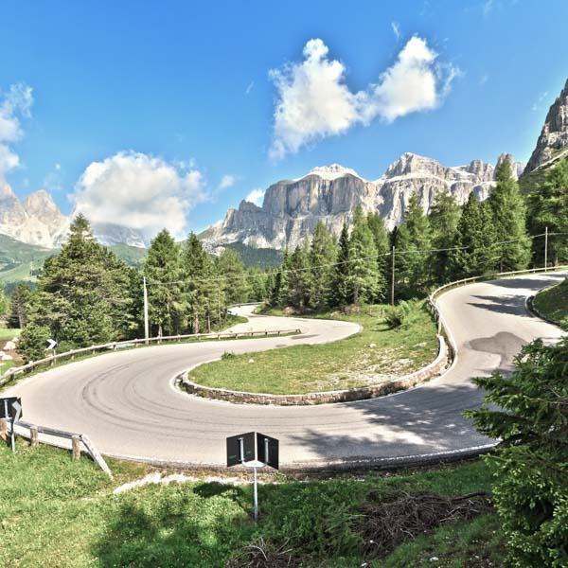
‘The Pordoi doesn’t need too much of an introduction. It’s one of the most famous climbs in world cycling and has made an incredible 39 appearances in the Giro d’Italia since its introduction in 1940. It’s a 20th century engineering masterpiece with no less than 33 hairpin bends and rises from the ski village of Arabba in a straight line at an almost constant 7%’.

Passo Sella
Routes Dol01, 06, 08 Maratona Short & Full
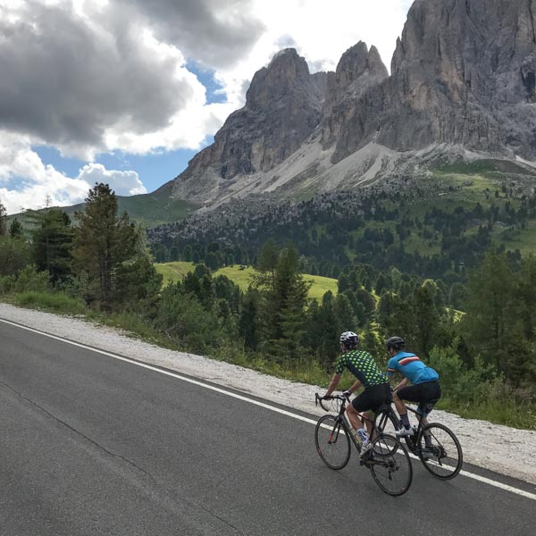

‘Passo Sella is one of those climbs that offers fabulous scenery as you are surrounded by the spectacular Sella Massif walls. The higher you climb you get an amazing view of the Marmolada Glacier and on the final hairpins you get your first glimpse of the magnificent Sassolungo group’.

Passo Gardena
Routes Dol01, 03a, 05, 06, Maratona Short & Full

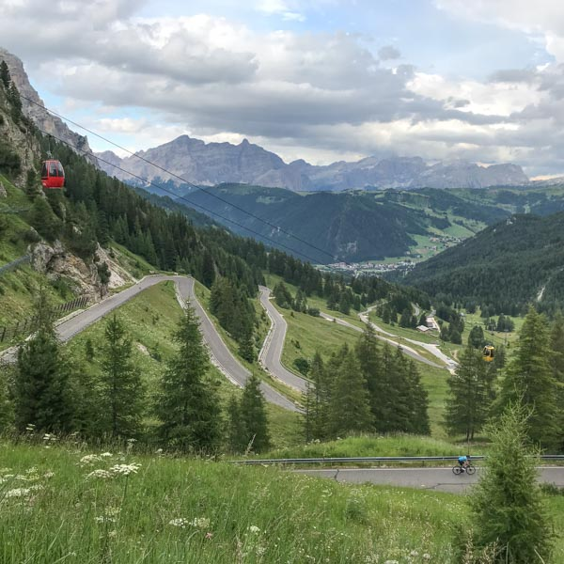
‘The first thing to know about this climb is that it’s drop-dead stunning, particularly as you reach the switchbacks towards the top. You’ve got the craggy, vertical peaks of the Sella and Cier ranges either side of you, and when you come over the top of the pass from Corvara, and the totally new view of the Sassolungo/Sasslong mountains opens up, it’s just a classic “wow” moment’.

Passo Giau
Routes Dol02, 07, Maratona Full

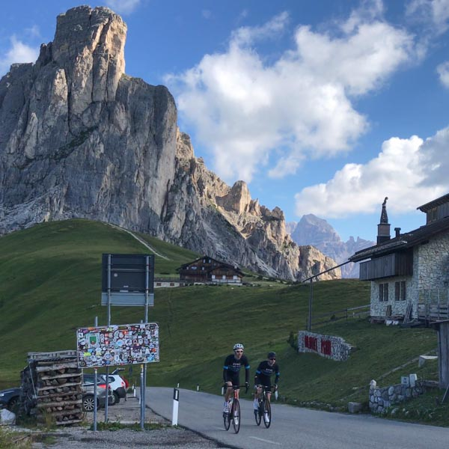
‘Sometimes referred to as the beauty and the beast, the Passo Giau is an extremely harsh and difficult test but is considered by many to be the most picturesque mountain pass in the Dolomites range. Standing at 2,236 metres above sea level the Giau boasts no fewer than 29 hairpin bends and is a relentless challenge of around 9% gradient over 10 kilometres’.

Passo Falzarego / Passo Valparola
Routes Dol02, 04, 07, 09, Maratona Short & Full

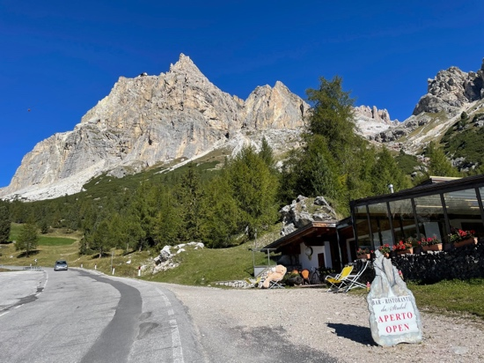
‘The Passo Valparola is the seventh and final climb of the Maratona dles Dolomites granfondo and is accessed via the Passo Falzarego. It is a strikingly beautiful pass rising up to 2,192 metres from dense woodland into a rocky landscape framed by giant mountains. It is also steeped in cycling history and people still speak of the incredible battle on this pass between Fausto Coppi and Gino Bartali in the Giro d’Italia way back in 1946’.

Passo Fedaia
Routes Dol06 & 09
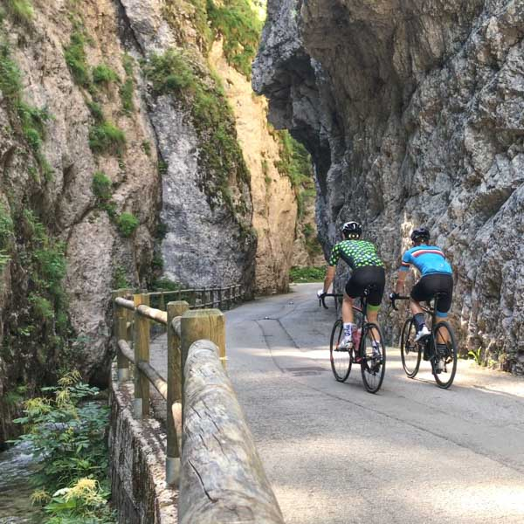
‘Whilst it’s not usually talked about in the revered terms associated with the Passo Giau or Pordoi, the climb to the summit of the Passo Fedaia from Caprile is thought by many cycling aficionados to be the best climb in the entire Dolomites range. It’s also one of, perhaps THE, hardest and has striking scenery. The Passo Fedaia lies at the base of the Marmolada (the highest peak in the Dolomites). It was used as a location for the ‘Italian Job’ film and one way to the summit takes you through the beautiful Serrai di Sottoguda canyon (temporarily closed due to rock fall). Whatever views people have on the Fedaia, the one thing that is indisputable is that it is a very tough climb, with the final five kilometres being particularly brutal’.

Tre Cime di Lavaredo
Route Dol11

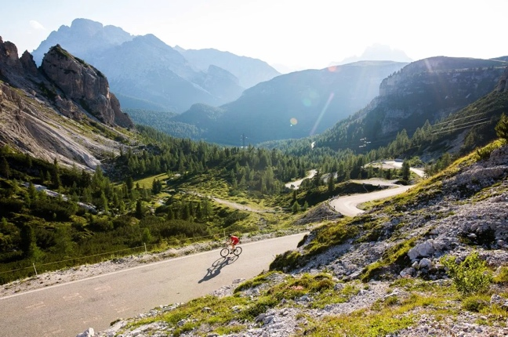
‘Tre Cime di Lavaredo is a climb like no other in the Dolomites, its final 4-kilometres have been discussed and feared ever since bike riders raced to the summit in the Giro d’Italia in 1967.
Known mostly for the mountaineering on the peaks that stand tall above the road, the mountains scenery is some of the most spectacular in the Dolomites and for the cyclist, even after a four-kilometre slog to the summit as abrupt and spectacular as anything they’ll ever face, this backdrop is the real attraction of the Tre Cime.’

Passo delle Erbe
Route Dol05

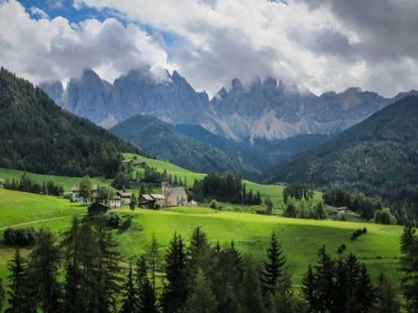
The Passo delle Erbe and into the Val di Funes ‘is truly the stuff of travel brochures. Lush meadows, clusters of timber-framed houses, and pockets of forest, all lorded over by the most eye-catching mountains anywhere on the planet’.

The Climbs in detail
Climb Name | Direction | Simon Warren Ref | SW Score | My Cols Rating | Length Km | Height gain  M | Ave Grad % | Max Grad % | Rte | Mrtna Climbs | Summit Alt M
Passo Campolongo | Corvara | 54 | 3 | Cat 2 | 6.0 | 357 | 6.0% | 10.0% | Dol02, Dol08, Dol09 | MS (twice), MF (twice) | 1,875
Passo Campolongo | Arabba |  |  | Cat 3 | 3.9 | 272 | 4.7% | 9.0% | Dol01, Dol04, Dol07 |  | 1,875
Passo delle Erbe | Longega |  |  | HC | 14.0 | 1,006 | 8.2% | 10.0% | Dol05 |  | 2,004
Passo di Falzarego | Cortina D'Ampezzo | 58 | 6 | Cat 1 | 15.8 | 904 | 5.7% | 9.0% | Dol02, Dol04 | MF | 2,105
Passo di Falzarego | Rocca Pietore |  |  | HC | 19.3 | 1,085 | 5.7% | 7.0% | Dol09 | MS | 2,105
Passo di Furcia | Longega | 55 | 7 | Cat 1 | 11.6 | 744 | 6.4% | 16.0% | Dol04 |  | 1,757
Passo di Sella | Plan de Gralba | 52 | 7 | Cat 2 | 5.0 | 356 | 5.0% | 11.0% | Dol01 |  | 2,240
Passo di Sella | Canazei |  |  | Cat 2 | 11.0 | 804 | 7.2% | 10.0% | Dol06, Dol08 | MS (half), MF (half) | 2,240
Passo di Valparola | La Villa | 57 | 7 | Cat 1 | 13.8 | 798 | 5.8% | 11.0% | Dol07, Dol11 |  | 2,198
Passo di Valparola | Cortina D'Ampezzo |  |  | HC | 17.2 | 950 | 5.5% | 8.0% | Dol11 |  | 2,198
Passo Fedaia | Caprile | 50 | 9 | HC | 14.0 | 1,045 | 7.5% | 16.0% | Dol06 |  | 2,057
Passo Fedaia | Canazei |  |  | Cat 2 | 10.7 | 588 | 5.7% | 8.0% | Dol09 |  | 2,057
Passo Gardena | Corvara | 53 | 5 | Cat 2 | 9.2 | 603 | 6.3% | 10.0% | Dol01, Dol03a |  | 2,121
Passo Gardena | Passua |  |  | HC | 24.0 | 1,057 | 5.1% | 8.0% | Dol05 |  | 2,121
Passo Gardena | Plan de Gralba |  |  | Cat 3 | 5.9 | 242 | 5.4% | 8.0% | Dol06 | MS, MF | 2,121
Passo Giau | Colle Santa Lucia | 59 | 9 | HC | 9.5 | 888 | 9.4% | 11.0% | Dol02 | MF | 2,236
Passo Giau | Cortina D'Ampezzo |  |  | HC | 15.6 | 896 | 9.4% | 15.0% | Dol07 |  | 2,236
Passo Pordoi | Canazei | 51 | 6 | Cat 1 | 12.1 | 785 | 6.5% | 9.0% | Dol01 |  | 2,239
Passo Pordoi | Arabba |  |  | Cat 1 | 9.3 | 653 | 7.0% | 9.0% | Dol09 | MS, MF | 2,239
Passo San Pellegrino | Cenceneniche Agordino | 49 | 8 | HC | 18.2 | 1,134 | 6.2% | 15.0% | Dol08 |  | 1,915
Passo Tre Croci | Cortina D'Ampezzo | 60 | 4 | Cat 2 | 7.9 | 556 | 7.0% | 9.0% | Dol11 |  | 1,805
Tre Cime de Lavaredo | Auronzo Di Cadore | 61 | 10 | Cat 2 | 6.9 | 548 | 9.6% | 13.0% | Dol11 |  | 2,362
Rifugio Pederu | St Viglio |  |  | Cat 2 | 15.9 | 535 | 3.4% | 8.0% | Dol12 |  | 1,540

The Routes
Click on the map to see the Garmin Connect route. Climbs and possible refreshment stops have been highlighted (except for the Maratona routes).

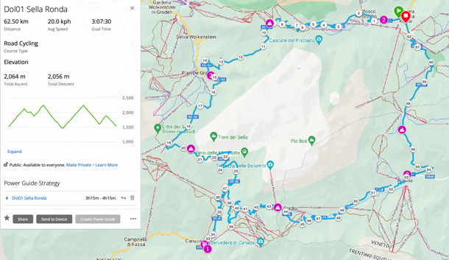

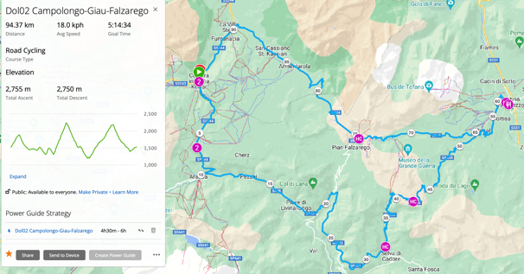

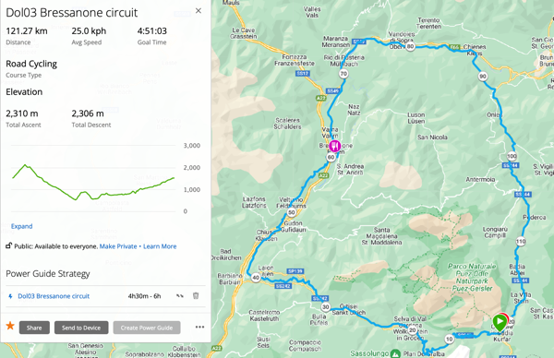

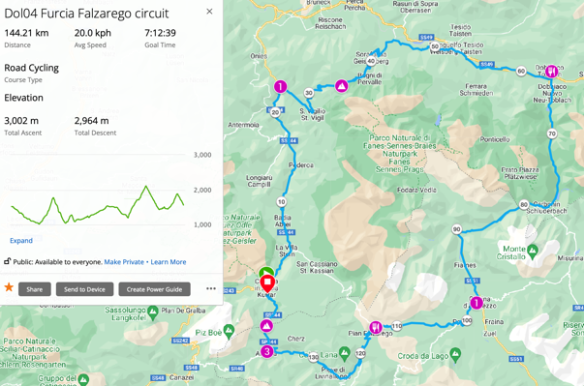

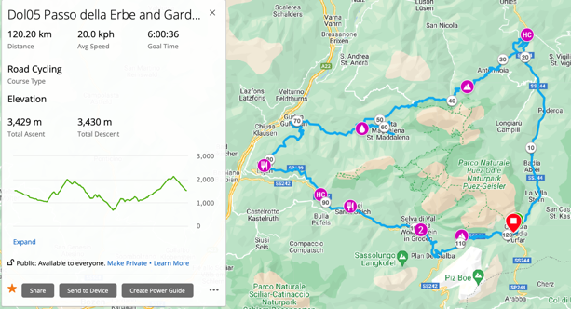

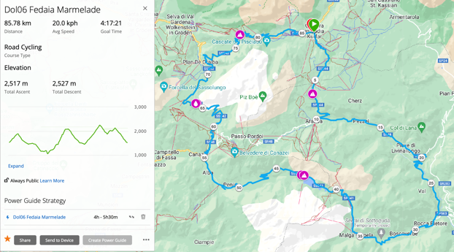

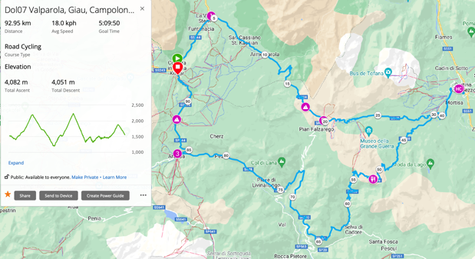

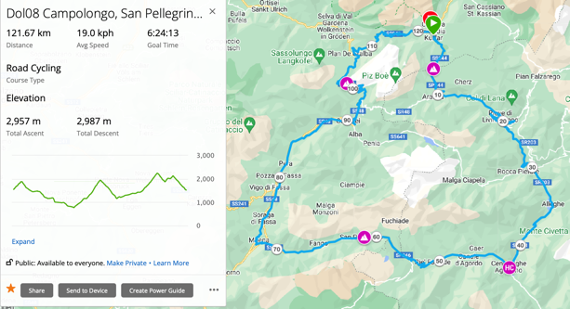

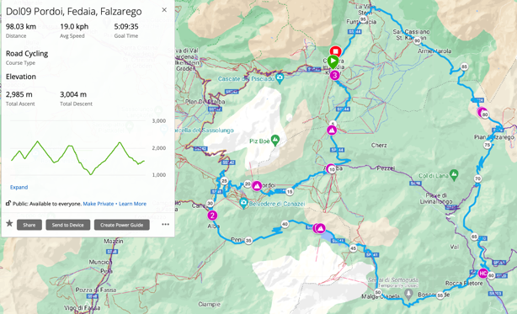

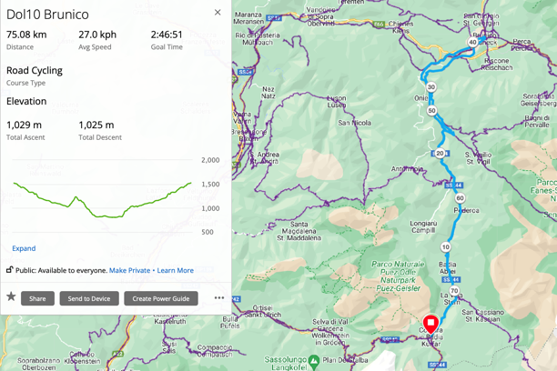

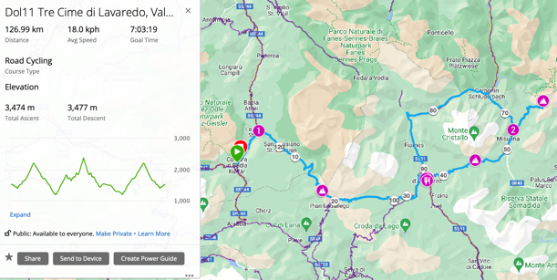

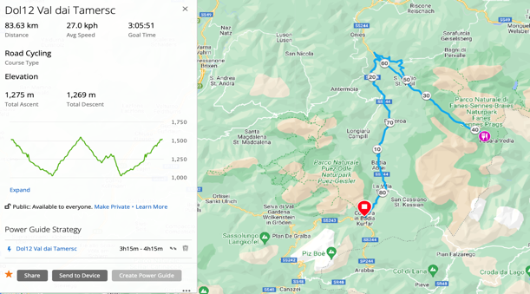
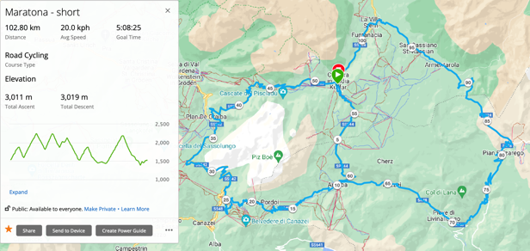

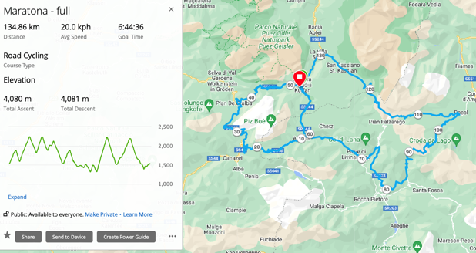

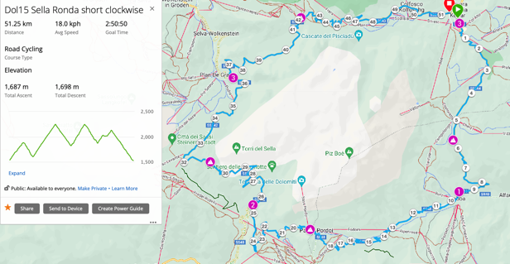

Suggested Itinerary & routes in detail
(Click on route name for link to Garmin Connect route. Suggested café stops and the main climbs are noted on the route and will pop up on compatible Garmin devices)

Suggested Day | Route Title | Km | Miles | Mtrs | Ft | M Climb per Km | Ft Climb per mile | Noted climbs & comments | HC | Cat 1 | Cat 2 | Cat 3
1 | Dol14 Sella Ronda short anti-clock | 51 | 32 | 1,701 | 5,528 | 33 | 175 | 53 Passo Gardena, Passo di Sella (short), Pass di Pordoi (part), Passo Campolongo (short) | - | 1 | 2 | 1
2 | Dol06 Fedaia Marmelade (clock) | 86 | 53 | 2,517 | 8,180 | 29 | 153 | 50 Passo Fedaia, Passo di Sella (rev), Gardena | 1 | - | 1 | 1
3 | Dol12 Val dai Tamersc | 84 | 52 | 1,275 | 4,144 | 15 | 79 | Valley floor café ride but with steady climbs | - | - | - | 1
4 | Dol02 Campolongo-Giau-Falzarego (anti-clock) | 94 | 59 | 2,755 | 8,954 | 29 | 153 | 54 Passo Campolongo, 59 Passo Giau, 58 Passo di Falzarego | 1 | - | 1 | 1
5 | Dol03a Bressanone Circuit | 127 | 79 | 2,387 | 7,758 | 19 | 100 | 53 Passo Gardena, long sections traffic free | - | - | 1 | -
6 | Dol11 Tre Cime di Lavaredo, Valparola, Tre Croci | 132 | 82 | 3,593 | 11,677 | 27 | 143 | 57 Passo di Valparola, Passo Tre Croci, 61 Tre Cime di Lavaredo, Valparola | 1 | 1 | 2 | -
7 | Dol15 Sella Ronda short clockwise | 51 | 32 | 1,687 | 5,483 | 33 | 173 | 54 Passo Campolongo, Passo Pordoi, Passo Sella & Passo Gardena | - | 1 | 2 | 1
 | Dol01 Sella Ronda (anti-clock) | 63 | 39 | 2,064 | 6,708 | 33 | 173 | 53 Passo Gardena, Passo di Sella, 51 Pass di Pordoi, Passo Campolongo | - | 1 | 2 | 1
 | Dol04 Furcia Falzarego circuit (anti-clock) | 144 | 90 | 2,999 | 9,747 | 21 | 109 | 55 Passo Furcia, 58 Passo Falzarego, Campolongo | - | 2 | - | 1
 | Dol05 Passo delle Erbe & Gardena (anti-clock) | 120 | 75 | 3,428 | 11,141 | 29 | 149 | Passo delle Erbe, Passo Gardena | 2 | - | - | -
 | Dol07 Valparola, Giau, Campolongo (clock) | 93 | 58 | 2,790 | 9,068 | 30 | 157 | 57 Passo di Valparola, Passo Giau, Passo di Campolongo (rev) | 1 | 1 | - | 1
 | Dol08 Campolongo, San Pellegrino, Sella (clock) | 122 | 76 | 2,957 | 9,610 | 24 | 127 | 54 Passo Campolongo, 49 Passo San Pellegrino, Passo di Sella (rev) | 1 | - | 2 | -
 | Dol09 Pordoi, Fedaia, Falzarego (clock) | 98 | 61 | 2,985 | 9,701 | 30 | 159 | Passo Campolongo, Passo Pordoi, Passo Fedaia, Passo Falzarego | 1 | 1 | 1 | 1
 | Dol10 Brunico | 75 | 47 | 1,029 | 3,344 | 14 | 72 | Valley floor ride with some busier roads - use tunnel alternatives where possible | - | - | - | -
 | Dol13 Sella Ronda full clockwise | 63 | 39 | 2,055 | 6,679 | 33 | 171 | 54 Passo Campolongo, Passo Pordoi, 53 Passo Sella & Passo Gardena | - | 1 | 2 | 1
 | Maratona - Full | 135 | 84 | 4,080 | 13,260 | 30 | 158 | Official full Maratona route | 1 | 2 | 2 | 2
 | Maratona Short | 103 | 64 | 3,011 | 9,786 | 29 | 153 | Official short Maratona route | 1 | 1 | 2 | 2

This looks to be a challenging week for cycling the mountains – every way is up! Routes have been developed to take in as many of the iconic climbs in the area as possible. The suggested itinerary tries to include a comprehensive selection of the climbs from their best aspect (without having ridden any of them before!!).

- None of the routes are particularly long (distance-wise), but they mostly have at least 2 long climbs
- To help acclimatise, the rides are planned to get steadily more challenging (distance & climbing) as the week progresses
- Routes that get recommended include Sella Ronda (Dol01, 13, 14 & 15) & Passo delle Erbe (Dol05)
- In particular it is proposed we ride the Sella Ronda on day of arrival (possible if transfer & hotel check-in go smoothly) – its only 39 miles, has spectacular scenery, but has 4 climbs! Shorter versions are available if we are running late (Dol14 & 15)
- Day 4 is intended as a more relaxing day (routes Dol10 or 12) – a flat ride or no riding at all
- Maratona (short or full) is possible at end of week but many of the climbs will have been done. This coupled with the fact that the Maratona is much harder than any of the other routes here, means I have not included it in the itinerary.
- I have tried to identify suitable cafes/refreshment stops, mostly at the top of the climbs and they are noted on the routes (for compatible Garmins only). However, there is no guarantee that they will be open.
- There are more routes than we need, allowing us to mix and change the itinerary
- Routes can obviously be done in either direction, but I have tried to plan them to get the best perspective & combination.

Road Safety
The routes try to take the quietest roads, however despite this they can be busy with other tourists and the lack of alternative routes for local traffic. In mid-September we experienced a large number of touring motorcycles, and a number of close passes. I would suggest using front and rear lights at all times to maximise your visibility to other road users.
Routes Dol03a & 10 have a section of tunnel on them. Lights should be used for these routes.

Weather
The weather in the mountains can be changeable so check weather reports before setting out and prepare accordingly. Of particular note is the temperature difference at the top of the climbs. Typically you should expect temperatures to be at least 10 degrees lower at the top of a climb than in Corvara. In addition there is a significant windchill factor on the descents so it is suggested you take at least 1 extra layer (and even 2!) to put on at the top after a climb.

For more information about the area and the climbs we will be doing, see the following sources and links:
https://www.epicroadrides.com/destinations/cycling-italy/dolomites/
http://www.cyclingdolomites.com
https://www.cyclist.co.uk/in-depth/1237/big-ride-dolomites
https://pjammcycling.com/zone/173.Dolomites-Bike-Climbs
https://www.cyclefiesta.com/multimedia/climbs/italy/italy.htm
https://www.colconquerors.com/holidays/ultimate-dolomites-cycling/
https://climbfinder.com/en/regions/dolomites
https://www.cyclingcols.com
Simon Warren 100 Climbs of Italy
My Cols phone app

